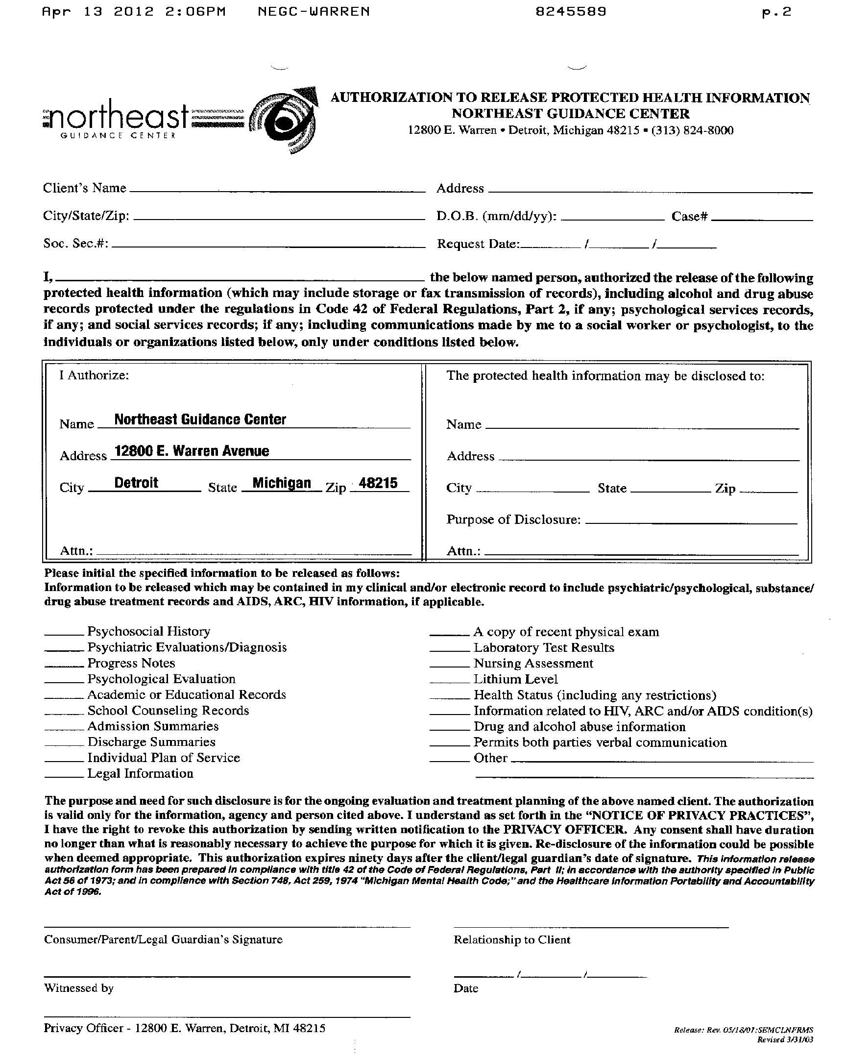
George Carey

Norristown, PA 19403
xxx-xx-1613
George Carey
54 Arbour Court
05/21/1949
January 28, 2016
Axiom Requisition Copy Service
2869 Jolly Road
Okemos
MI
48864
Litigation
Records Department
FROM 05/21/1949 TO PRESENT: Any and all MEDICAL RECORDS, including but not limited to patient history form(s), reports, etc. pertaining to George Carey SSN: xxx-xx-1613, DOB: 05/21/1949.

